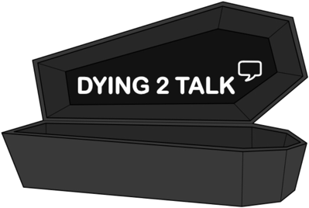
At my funeral…
What would you like at your ideal funeral?

Where would you like your funeral to be held?

What would you want people to wear?

What song(s) would you want played?

What food would be served?

Would you prefer to be buried or cremated?

What would you like be done with your ashes?

Where would you want to be buried?

Would you want to buried with anything?

How do you want to be remembered?

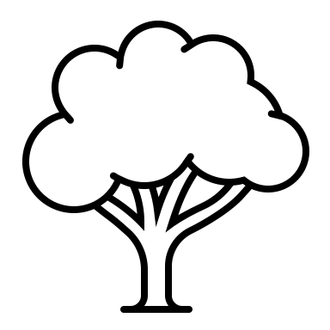
Would you donate your organs?

